
Reception Term 1a
Literacy:
- own names and others names recognition.
- name practice.
- letter recognition/formation books.
- lists and labelling.
- talking about self ...likes and dislikes etc.
- Storytelling (Funny Bones) sequencing and nursery rhymes (Head Shoulders....).
- The hungry caterpillar- making own version of book
Phonics:
- introduction of sounds - sound recognition and imitation.
- phonics rhyme.
Islamic Studies:
- Aadaab – saying salaam and jzk.
- Akhlaaq – families, respect for others.
- Duas – children to start learning duas.
- Stories and nasheeds- I am Muslim.


Ourselves / Staying Healthy
‘Love for your brother what you love for yourself’ Hadith
Maths:
- counting one to one, recognising numbers
- matching numerals to quantities
- name ad describe 2D shapes
- repeating patterns
- counting and adding, saying the next number
- addition to 5
Understanding of the World:
- talk about healthy eating in importance of maintaining optimal health.
- making sandwiches, fruit salad etc.
- ‘All About Me’ booklet/ talking about family members.
- Technology - drawing pictures of themselves.
- seasons- collecting leaves.

PSED:
- making friends.
- team building.
- home life/families.
- interests and hobbies.
- learning the rules.
- learning routines of school day.
- knowing about ourselves and what we can do.
EAD:
- self portrait – our families.
- making funny faces – decorating biscuits.
- collages of face/ bodies.
- finger/ hand painting.

Areas:
- Role Play – acting out everyday scenarios, acting as individual family members, going shopping etc
- Literacy/writing – cutting and gluing body parts, formation of letters, name
- Maths – number formation, number recognition, addition , shapes
- Reading – Funny bones book, the Very Hungry caterpillar books on body parts, feelings, family etc.
- Creative – Colouring and painting body parts, finger painting, collaging body outlines, The hungry Caterpillar, favourite fruit.
- Investigation – using magnifying glasses to examine body parts and draw them. Looking at seasons, collecting leaves
- Construction – building towers and blocks, building houses, garages etc,
- Outdoor – Literacy and Maths related activities on easel and in sand and water.
PD:
- gross motor skills – holding pencil correctly, using scissors properly etc.
- playground games.
- toilet hygiene and routine.
P.E
- moving freely in own space.
- body shapes.
Reception Term 1b
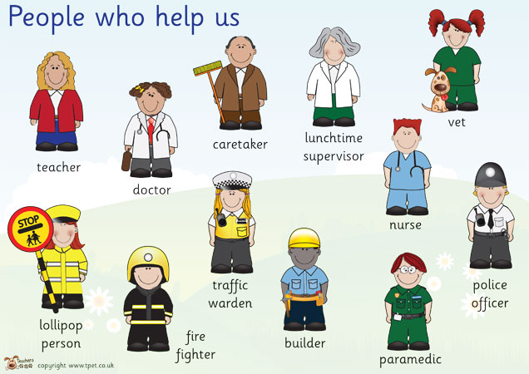
Literacy:
- Learn why we write letters and how to address an envelope .
- Doctor- writing appointment slips.
- Police- Pc fizz, Write questions they would like to ask a police officer.
- Dentist- oral health- instructions cut and stick how to brush teeth.
- Fire fighters – labelling a fire engine.
- Postman- post card with address, write letters to their friends.
Phonics:
- Progression of phonic stages .

Islamic Studies:
- Aadaab – listening to parents, not talking to strangers.
` paradise lies under the feet of your mother.`
- Akhlaaq- how to talk with respect .
- Duas- continue learning next duas.
- Nasheed- My Mother


Poeple who help us
‘Allah helps those who help us .`
`The best among you are the ones who help others. – Hadith
.’
Maths:
- counting and adding - saying the next number
- read the corresponding addition
- size and length
- describe 3D shapes
- Recognise £1 and £2 coin
- Days of the week

Understanding of the World:
- Watch a clip of the journey of a letter.
- Magnifying glasses- look at fingerprints.
- Talk about match safety.

PSED:
- early learning goals.
- not talking to strangers.
- looking after property.
- not touching what does not belong to us.
- Talk about how people help us.

EAD:
- leaf printing.
- collage of bears.
- make split pin characters.
- junk modelling – cereal boxes, houses.

Areas:
- Role Play – Doctors surgery/ police station/dentist/ travel agent/ post office.
- Literacy/writing – appointment slips/ design and name own police officer/ writing post cards to friends
- Maths - number formation/ Exploring 3d shapes/ recognising money/ days of the week
- Reading – books on people who help us.
- Creative – leaf printing/ colouring different people who help us/ painting/ collage.
- Investigation/ Construction – journey of a letter/ going on a walk
- Little Finger Gym

PD:
- go on bear hunt rhyme.
- go on a walk.
- outdoor textures: twigs, leaves, stone.
P.E:
- Moving around freely.
- Act out `we`re going on a bear hunt.`

Reception Term 2a
Literacy:
- Hungry Caterpillar- write list of different food.
- Not so Boring day- story sequences- beginning middle and end.
- Letter writing
- The fantastic fable of fussy Frank- Which fruit or vegetables is liked/disliked.
- The hungry Caterpillar - story sequencing / factual and fiction sorting.

Phonics:
- Progression of phonic stages. – begin to write sentences.
Islamic Studies:
- Adab- our bodies are an amanah from Allah (swt).
- Akhlaaq - discuss overeating and its effects.
- importance of looking after animals Suliman (AS) story.
- Nasheed- animals love to hear quraan


Maths:
- Recite to 100: count 20 objects
- estimate, count numbers, ordinal numbers
- 2D shapes- sorting
- addition-find one or two more.
- pairs with total of 10.
Understanding of the World:
- minibeast hunt.
- habitats of mini beasts looking at their similarities and differences.
- lifecycle of butterfly and frog.
- planting cress/ sunflower planting
- growth
- Technology- drawing and painting minibeast, adding body parts.

PSED:
- discuss fear of spiders/ worms.
- how to overcome fear.
- care and concern for animals.
- how we can keep ourselves healthy by growing and eating our own fruit and vegetables.
EAD:
- symmetrical butterfly with paint.
- general pattern making.
- mosaics with patterns.
Areas:
- Role Play – VET/
- Literacy/writing – list of different food/ story sequencing / likes and dislikes of food/ factual and fiction sorting
- Maths - exploring 2D shapes/ addition/ pairs to 10
- Reading – animal books/ human body growth
- Creative – symmetrical butterfly painting/ collage / painting
- Investigation/ Construction – Minibeasts hunt/ life cycle of a frog/ sunflower planting
- Little Finger Gym

PD:
- Experiment different ways of moving ( different stage of life.)
- Showing increasing control and confidence and skill around under over and through balancing and climbing equipment.
P.E
- running, jumping, crawling like animals.
- Movement like animals
- moving like animals.


Change & Growth/ Mini Beasts.
`Whoever is kind to Allah`s creatures, Allah is kind to him.`

Reception Term 2b
Literacy:
- Duck in the truck story.
- Sort out what is transport and what is not .
- Write sentences of favourite transport ( using photos).
- Making passport.
- Luggage labels
- Holiday postcards.
- List of what to take on holiday.
- making holiday tickets
- Where we would like to go on holiday.
Phonics:
- Progression of phonic stages .
Islamic Studies:
- Akhlaaq/ adab - keeping your house clean and your classroom. Self cleanliness.
- Discuss hajj.
- Nasheed- oopsy daisy.

+
Travel and Transport.
` When three people set out on a journey , they should appoint one of them as their leader`.
Hadith
Maths:
- Two more than
- weight- estimation of which object is heavier
- 3d shapes
- counting and comparing
- money and counting

Understanding of the World:
- Map making – which way they come to school.
- Compare past and present transport.
- Road safety.
- Bus tickets/train/ aeroplane tickets.
- Making paper planes

PSED:
- Road safety
- Discuss personal journey the children have been on.
- Use chairs to be an impromptu bus/plane and car.
- Talk about rescue vehicles – ambulance, fire engine , helicopter.
EAD:
- Tyre prints
- Make paper aeroplane
- Making post cards
- Colour bus/ car/ aeroplanes
- make cars
Areas:
- Role Play – travel agent- ticket booking/ going on a holiday/ suitcase packing
- Literacy/writing –
- Maths - money/ explore 3D shapes/ weight estimation/ counting and comparing
- Reading – travel brochures/ holiday magazines.
- Creative – type print/ paper aeroplanes/ making postcards/ colouring /painting different types of transport
- Investigation/ Construction – making transport/ making maps
- Little Finger Gym
PD:
- Transport mimes- getting on train, boat and car.
- follow the leader
- Stop /go games using traffic lights colours
- .learning how to skip.
- set up an obstacle course for children to travel on
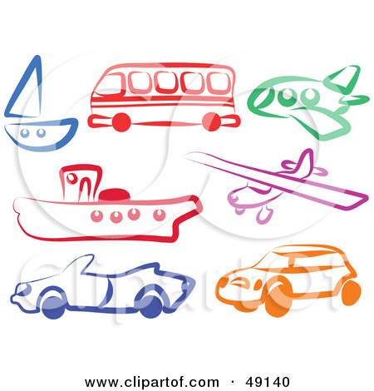

Reception Term 3a
Literacy:
- St George and the Dragon - Draw and label dragons and fill in character profiles.
- Ginger Bread Man – designing Gingerbread men , rhyming poem, performing the story.
- The Three Billy Goats Gruff- story sequencing . Re –act the story.
- Little Red Riding Hood – Creating goodie baddie characters.
Phonics :
- introduction of sounds - sound recognition and imitation. Introduces actions.
- phonics rhyme.
- Higher- Diagraphs

Phonics:

Islamic Studies:
- Allahs creation/ how we look after animals.
- Story about Suleman (a.s) talking to animals.
- Story about woman feeding the dog and earned jannat.
- Story about neighbours.
Nasheed- Sabr and Shukr

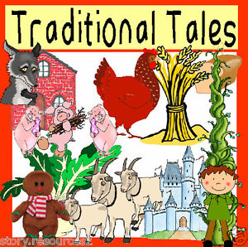
Traditional Tales
Indeed , we have created the human being upon the best of forms.’ Quranic
Maths:
Time : Children to learn O` clock. Days of the week and months in the year.
Counting in twos: children to use fingers and objects to help count in twos
2d shapes: children to sort shapes using corners. Children to be able to name 2d shapes.
Find one more and one less: count back by taking two objects away.
Record numbers to 20: Count on or back 2 or 3.

Understanding of the World:
- materials area – wood, texture soft, hard, smooth.
- gingerbread men.
- buying items with money
- Technology- story sequencing . label materials

PSED:
- Talk about why we have rules/ why its important to have them.
- Talk about how people help us.
- Children talk about how they and others show feelings, talk about their on and others behaviour and its consequences and know that some behaviour is unacceptable.
EAD:
- collage of bears.
- make split pin characters.
- junk modelling – cereal boxes, houses.
- Pattern making

Areas:
- Role Play – Imitate Little Red Riding Hood, Gingerbread Man, Children will have opportunities to play different characters (good and bad). doctor surgery and police station
- Literacy/writing – Little Red Riding Hood good and bad character profiles, Story of Gingerbread Man, appointment cars, police incident forms
- Maths – addition, length, 3D shapes, money, time.
- Reading – All Traditional Tales books will be out for children to explore.
- Creative – Making props for characters, food items etc with play dough, painting and colouring characters.
- Investigation – Checking materials to determine strength, Taking walk round local area/ environment, Weather and appropriate clothing.
- Construction – Build cottages, making woodlands, towers, gingerbread men.
- Outdoor – Literacy and maths related activities in sand and water.

PD:
Jumping - children to learn the correct techniques of jumping. Children practice jumping on the spot and then moving forward or backwards jumping .Jumping off a bench: children to stand on benches and learn to balance on them. Play team games using benches. Children to learn how to jump off an bench the correct way. Practicing skipping skills.

Reception Term 3b
Literacy:
- Recapping over everything.
- Rhyming words- making rhyming strings.
- Practice writing sentences.
- Make a scrap book.

Phonics:
- Recap over all taught graphemes and diagraphs.

Islamic Studies:
- Allahs creation- sun, moon and stars.
- Importance of using the day wisely- talking about how we should sleep at night.
- Nasheed - Give thanks to Allah.
Electricity/ Light and Dark.
` God is the light of the heavens and the earth.`- Quranic Aayat
.
Maths:
- Odd and even numbers
- Recap over shapes
- Revise over addition and subtraction
- Recap number ordering
Understanding of the World:
- Gadgets – broken equipment.
- Light and dark
- Electricity

PSED:
- Children are confident to try new activities and say why they like some activities more than others.
- Confident to speak in familiar group, will talk about their ideas and choose resources they need for their chosen activities.
EAD:
- Fireworks
- Sun and moon templates decorate them.

Areas:
- Role Play – act of the day and night time routine
- Literacy/writing – making scrap books/ rhyming string
- Maths - recap over shapes/ number ordering/ addition and subtraction
- Reading –
- Creative –fireworks/ daytime pictures/ nighttimes pictures/ sun, moon and star decoration
- Investigation/ Construction –
- Little Finger Gym

PD:
- Begin to use anticlockwise movement and retrace vertical lines.
- Show increase control over object in pushing patting, throwing and catching or kicking it.
P.E
- Cricket
- Catching and throwing

