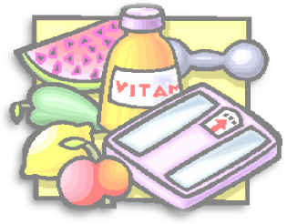
P
PSHCE
Health and wellbeing Linking with Science Balanced diets
Disabilities and discrimination
Recognising choices
Rights of other people
Making right choices with food
Understanding feelings and to be able to talk about feelings using a range of vocabulary.

Literacy:
Week1: Creating sentences about favourite types of fruit and vegetables including all punctuation and grammar into the sentences. Learn and be able to spell names of fruits and vegetables that are not mainstream and heard often.
Week2: Creating shape poems based around the teeth and keeping them healthy. Healthy poem in the shape of the mouth and teeth.
Week3: Creating poems based on healthy eating. Food poems or food related poems.
Week4: Plan and write a short story based on “going to the dentist” and experiences at the doctors.
Week5: Writing a play script based on the stories written in the previous weeks work as a group
Week 6:Individually write a play based on a healthy experience. Know the names of all the teeth and be able to spell them.
Week 7:Create a full length story on an experience based around health.
e.g. a trip to the doctors, a trip to the dentist
History
Julius Cesar and the origins of the Cesar salad.
The Roman Empire and their Army
The Roman Empire and their impact on Britain.
Invasion of Claudius and the conquest of Hadrian’s Wall

Guided Reading
Reading George’s marvellous medicine.
Discussing keeping healthy and eating god food.
Talk about the effects that different food can have on a person
eg. Unhealthy foods can cause sickness
foods that give strength

Islamic Studies
Akhlaq wal Adaab
Knowledge
Being kind
Helping the needy

PE:
Catching and throwing whilst saying a name of a fruit or veg. Not allowed to repeat the same word

Salaah/Reflections
Hadeeth related to looking after yourself.
Eating till 1/3 of the stomach is filled.
Which foods are mentioned in the quraan and their remedies.

Seerah
Diet of the Prophet SAW and the sahabas.
Arabia pre Islam
The birth of Rasullullah SAW
Childhood
Adulthood
Loss of Family
Prophethood

Art/DT
Still drawing of fruit.
Primary/secondary colours
Patchwork project
Tone /2D shading(form)
Warm and cool colours/Favourite palette.
Tone
ICT
Unit 3.1
Research healthy foods/diets/lifestyles
Collecting data
Recording results
Draw a bar graph
Create a healthy lifestyles power point

Dua/Nasheeds:
Duas to recited before eating and after and on receiving fruits for the first time in its season .
Nasheed about food
Numeracy
Number, place value and money
Revise putting 2 digit numbers on the number line.
Mental addition and subtraction
Addition and subtraction facts up to 20
Mental addition and subtraction
Add 2-digit numbers by partitioning
Subtract by counting up (answers less than 20
Shape or measures or data
Recognise lines of symmetry, complete symmetrical drawings
Mental multiplication and division
Double 2-digit numbers up to 50
Number, place value and money
Add using place value
Mental addition and subtraction
Add 100s, 10s and 1s
Mental addition and subtraction
Know multiples of 5 which total 100

Science
Week 1 Session A Food groups (1 week)
Revise what humans and animals need to be healthy and grow. Learn the correct vocabulary for food groups and do some fun activities online. Sort food into groups and make an illustrated vocabulary list.
Week 2 Session B Balanced diet (1 week)
Revise the vocabulary of food groups. Discuss different diets & the need for a balanced diet. Make a large class food pyramid display. Design favourite healthy balanced meals. Look at food packaging details. Briefly consider food miles.
Week 3/4 Session C Transport(2 weeks)
Find out how food is broken down into smaller bits in our mouths, stomach & intestine. These small nutrients are absorbed into the blood stream (circulatory system), which acts like a transport system to deliver nutrients to all parts of the body.
Week 5 Session D Skeletons ( 1 week)
Discuss the main functions of skeletons: support, protection & movement. Find out that muscles are also needed for movement. Children feel their own bones & draw & label a skeleton. Talk about broken bones & look at some X-rays.
Week 6 Session E Compare skeletons (1 week)
Find out that some animals have exoskeletons. Compare them with endoskeletons like humans have. Examine some sterilised bones closely & identify some properties. Link to fossils. Compare other endoskeletons with that of ahuman.
Week 7 Session F Muscles & joints (1 week)
Time for some muscle building! Children look at joints in the human body & the movements that each allow before looking at how muscles control every move we make. Models are constructed to show how pairs of antagonistic muscles pull to work together.
Week 8 Session G Effect of exercise (1 week)
Now let’s get moving! It will be red faces and huffing and puffing all around as the children feel the effects of exercise on their own bodies. During the exercises they record how they are feeling and measure changes.

Keeping healthy/teeth Term 1A

PSHCE
To be able to differentiate between the terms risk and hazards in different situations. Link risk and hazards in the safari.
to deepen their understanding of risk by recognising, predicting and assessing risks in different situations and deciding how to manage them responsibly
to recognise their increasing independence brings increased responsibility to keep themselves and others safe

Geography
Travel/Transport throughout history. Influential inventors.
Bronze age religion
Stonehenge
Stone Age and iron Age

ICT
Unit 3.4
Keeping Safe online
Text forums
Keeping safe on social media
Using range of digital devices to accomplish given goals.

Numeracy

Number, place value and money
Day 1: Place 3-digit numbers on a number line
Mental addition and subtraction
Day 1: Add pairs of 2-digit numbers using different strategies.
Written addition and mental subtraction
Day 1: Add 3-digit numbers using expanded addition.
MEASURES/DATA Length, weight, bar charts
Day 1: Measure in metres and cm; convert cm to m and vice
FRACTIONS
Day 1: Place fractions on a number line (1/4s 1/2s, 1/8s).
Number, place value and money
Place value in 3-digit numbers including money.

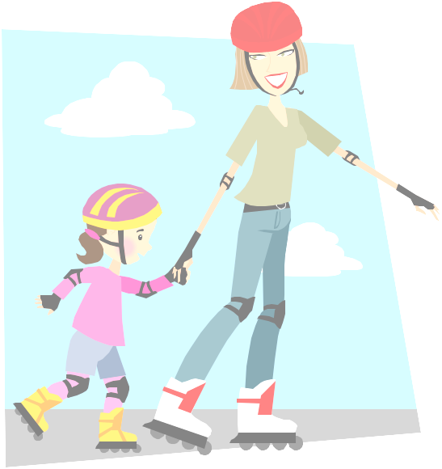
Literacy:
.Watch and listen carefully to a game show programme, Discuss the programme format. Identify features of instructions including type of vocabulary used.
Write a set of simple instructions.
.Rehearse features of instructional writing.
Identify and use imperative (bossy) verbs. Use powerful verbs.
. Recognise verbs in the present tense. Understand that writing can be in the 1st or 3rd person. Change the person (and verb tense) in sentences.
. Compare a recount with an explanation. Identify verbs and time connectives in a recount.
. Write a shared overview of a game show. Use appropriate handwriting. Write a first draft of an explanatory text about a game show.
.Understand that diagrams can be useful in making explanatory texts clear.Draw a diagram to explain a game.
.Understand the use of sub-headings to clarify explanatory texts.
.Research and write some questions and multiple-choice answers for a game show. Listen carefully to rules for a game show. Join in with a class game show following the rules.
P.E: Athletics
.apply and develop broader range of skills by showing control, co-ordination and consistency when running
.show control coordination when jumping/throwing
.keep and follow rules
.understand that they can run at a high speed over short distance.
. Understand how to pace your speed when running over a increased distance.
.learn to sprint? Jump for distance

Islamic Studies
Hadith Al Muslimu- How we should not hurt anyone physically or verbally
When is wudhu necessary
Sunnah method of ghusl
Conditions of Salaah
Athaan

. Sallah/reflections
Learn the words to full salaah
Learn the practical/ actions
Learn the names and times of salaah is read/ how many rakaats they are

Guided reading:
George’s marvellous medicine. To experiment with the order of sections- challenges the children to remember all the ingredients used for medicine..To use settings to engage reader’s interest- get children to create sentences and pictures about what grandma can see on the roof: her thoughts .To deduce characters reasons forbehaviour fromtheiractions- children to discuss character of Mr Kranky. To compare different types of narrative and information text ask children to a set of instructions in groups.

Seerah
Marriage
Building of the kabah
Arab towns and tribes
How the prophet SAW treated youngsters and looked out for them

Art/DT Pop up Story book
about pop-up books and why they are so popular/how different card mechanisms create different sorts of movement;
how different card mechanisms create different sorts of movement.
about the accurate cutting, scoring, folding and joining techniques needed to produce working, reliable cardmechanisms;
to measure, mark out, cut and shape a range of materials, using appropriate tools, equipment and techniques
to develop different graphic styles and match these to the needs of different audiences;

Learn the nasheed: I am a Muslim
Learn new duaas on their sheets
Learn duaas: going sleep/ waking up/ traveling/ rain /
Learn kailmahs: 1/2/3

Science
.

Session A Pushes and pulls
Remind chn of work on changing the shape of solid objects in Y2.Discuss what we mean by forces, pushes & pulls requiring direct contact. Learn how to use arrows to show the direction of forces. Choose a setting to illustrate forces & their directions.
Session B Different surfaces Discuss how different things move, e.g. with simple pushes or pulls, or by wind, water, clockwork, electricity, radio control, etc. Chn set up an enquiry about how far toy vehicles move on different surfaces & draw conclusions from their findings.
Session C Natural magnets & compasses
Look at a naturally occurring magnetic rock called lodestone (magnetite). Learn about the origins of, and myths about magnets. Find out how a compass works, and make a simple one. Use mnemonics to learn the main 4 compass directions & play Simon Says.
Session D Magnetic materials
Explain that materials that are attracted to magnets are called magnetic. Identify magnetic & non-magnetic materials in the classroom. Set up an enquiry to find out if all metals are magnetic. Discuss using magnets to sort recycled materials.
Session E Attract and repel
Use bar magnets to find out like poles repel & opposite poles attract. Explain Earth acts like a large bar magnet & that two poles are called north & south. Emphasise that magnetic forces act at a distance. Demonstrate magnetic field using iron filings.
Session F Uses of magnets
Explore a range of different shaped magnets, identifying their poles. Use sealed iron filings to show the magnetic fields. Discuss everyday uses of magnets at home, at school and in games/toys. Chn design a new product using magnets for Dragon’s Den.

Keeping Safe
Term 1b

