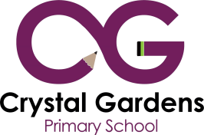
Themed Curriculum Overview
 | Reception | Year 1 | Year 2 | Year 3 | Year 4 | Year 5 | Year 6
Term 1a | Ourselves / Staying Healthy | Family | Growing / Development | Keeping healthy / Teeth | Staying Healthy | Growing / Development | Rivers
Term 1b | People who help us / the environment | People who help us / the 4 Seasons | People who help us / Keeping Safe / Anti Bullying
Term 2a | Change and Growth / Mini Beasts | Gardeners World | Celebrations / Festivals | Safari | Rain Forests | Marine Life | Desert
Term 2b | Travel | Jungle | Europe | America | Asia | Aztecs / Middle East | Africa
Term 3a | Traditional Stories | Fairy Tales | British History / Democracy |  |  | Victorian Times | Tudors
Term 3b | Electricity | Space | Transport | Democracy / Monarchy

